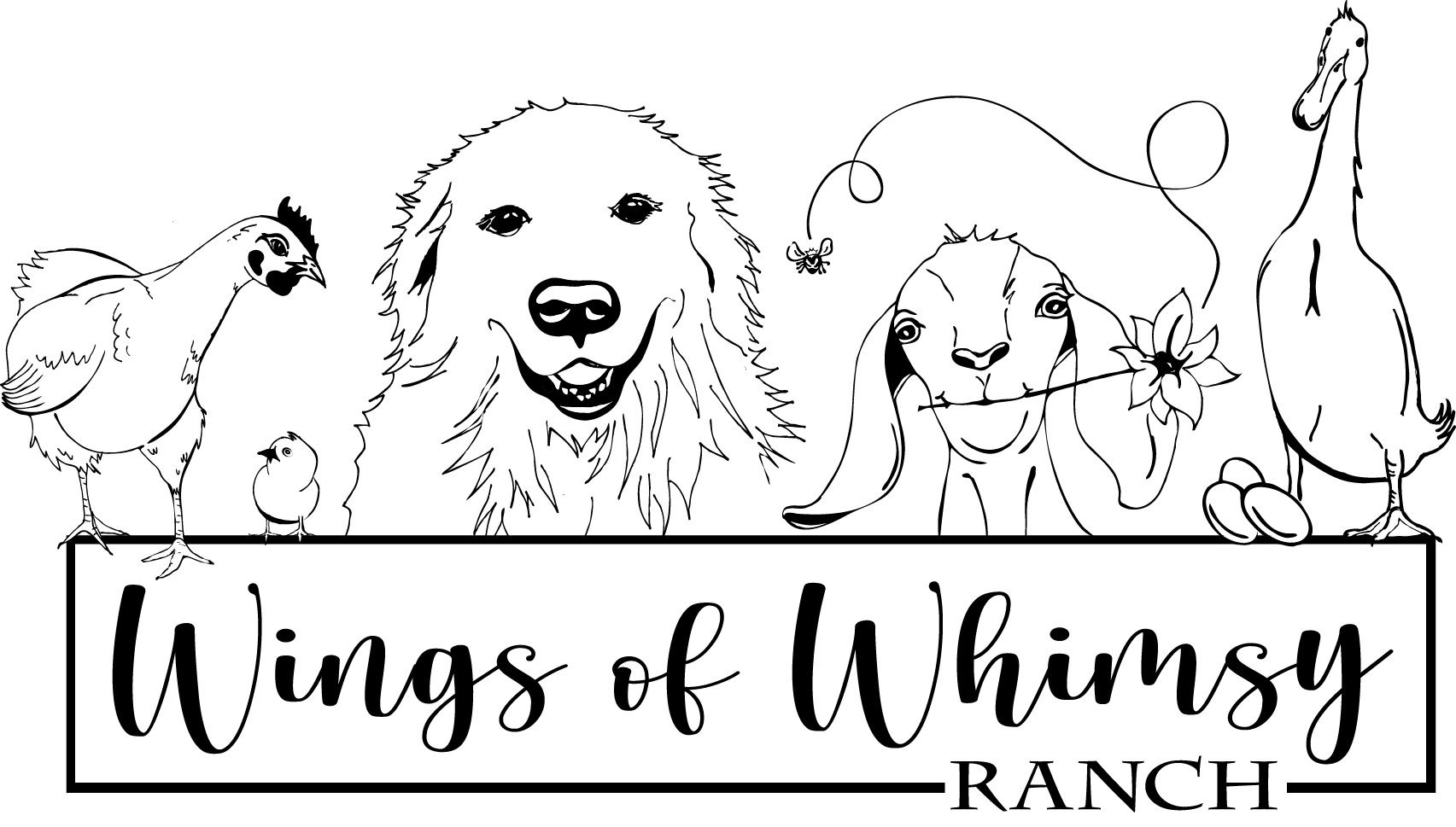
Wings of Whimsy Ranch, LLC. - 7920 Hygiene Road, Longmont, CO 80503 - (734) 417.6755

COLORADO MOUNTAIN DOG SALES CONTRACT
This is a legal contract entered into between Wings of Whimsy Ranch, LLC and the buyer specified below. This document is the only agreement between buyer and seller. No verbal agreements shall modify this agreement.

Buyer name:_________________________________________________________________________

Address:____________________________________________________________________________

___________________________________________________________________________________

Phone:_____________________________________Email:____________________________________

Puppyś Sire:___________________________________Puppyś Dam:____________________________

Puppyś Name:__________________________________________________DOB:__________________

Gender:____________________Color:________________________Intended Use:_________________

Purchase Price / Payment
A deposit of $___________ has been received for the puppy described above.

The balance of $_____________ will be due before delivery of the puppy.
All payments must be made in the form of cash, cashier’s check, money order or personal check made payable to Wings of Whimsy Ranch, LLC.
All travel and / or shipping charges are the responsibility of the buyer and are not included in the purchase price or deposit. It is highly recommended by WOW Ranch that the buyer personally pick up their puppy.
Deposits are non-refundable, but may be transferred to another litter if no puppies of the requested gender are born. The puppy must be selected by 8 weeks of age. Once the puppy has been selected the deposit is no longer transferable. The deposit will hold the selected puppy until 9 weeks of age. If the puppy cannot be picked up or shipped in a timely manner, an additional fee of $5 per day will be charged to cover board and early training. Full purchase price for the puppy and additional shipping / travel charges must be paid before delivery of the puppy.
Buyer understands and agrees with the terms stated above.

Signature of Buyer:___________________________________________________Date:__________________

Buyers Responsibilities
Please read and initial each block below. Please note that WOW Ranchś puppy/dog guarantee is null and void if buyer does not adhere to the following Buyer Responsibilities.
_________ If, at any future time during the life of your WOW Ranch Livestock Guardian puppy/dog, the Buyer is unable to keep the above described puppy/dog, WOW Ranch will either take the puppy/dog back or make every reasonable effort to help the Buyer rehome the puppy/dog. If the puppy/dog is returned to WOW Ranch, all registration papers must also be returned to WOW Ranch. The puppy/dog is not be placed in an animal shelter or destroyed/euthanasia (exception to euthanasia would be if the puppy/dog has come to some mishap and sustained significant injury or is suffering). Buyer will be required to sign a surrender contract at the time of surrender stating that they are transferring all rights of ownership back to WOW Ranch. WOW Ranch will not reimburse the Buyer for the cost of the puppy/dog or any other expenses incurred. Delivery costs for shipping dogs back to WOW Ranch are the responsibility of the Buyer. The puppy/dog must have a veterinary health certificate prior to being brought back to WOW Ranch.
__________Every effort has been made by WOW Ranch to produce a litter/dog that is both physically and mentally sound. WOW Ranch will stand behind this litter/dog to the extent stated below. However, Buyer accepts full responsibility for proper care of puppy/dog once said puppy/dog leaves WOW Ranch, as WOW Ranch can not be held responsible for death, injury, deformity, or temperament of the puppy/dog due to illness, accident, or deviation from adequate care and socialization required for the Large Breed (Colorado Mountain Dog) puppy/dog.
__________Buyer will assume responsibility for all transportation and shipping costs. Transportation and shipping is at the risk of the buyer. Buyer releases WOW Ranch of all responsibility for the puppy/dog at the time the puppy/dog leaves the care of WOW Ranch prior to transport. As a buyer, I understand that it is my choice to have the puppy/dog shipped/transported and that I am solely responsible for any problems incurred during shipping or after as a result of shipping/transporting.
__________Buyer agrees to have this puppy/dog examined by a licensed veterinarian within 10 days of receipt and to provide a copy of the results of that visit to WOW Ranch. If health problems are found, the puppy/dog along with all registration papers may be returned to WOW Ranch within 14 days of receipt for a full refund or replacement. WOW Ranch discretion is used to determine the best arrangement. However, if the buyer elects to keep the puppy/dog after the required veterinary exam, WOW Ranch is not liable for any existing or future medical conditions except as noted under -Breeder Guarantee. WOW Ranch is not responsible for any veterinary expenses incurred by the buyer.
__________Buyer agrees to have this puppy/dogś hips x-rayed between 24-30 months of age and submit results to Colorado Mountain Dog Association. The buyer assumes all x-ray costs. If hip dysplasia is diagnosed, the buyer agrees to sterilize (spay or neuter) the afflicted dog.
__________Buyer agrees to honor any spay/neuter clauses specified in this agreement.
__________Nothing in this agreement shall be construed as liability of any kind on WOW Ranch´s part if the puppy/dog fails in any way to perform its intended functions for any reason, nor shall WOW Ranch be liable for any actions of this puppy/dog.

Failure to adhere to these conditions shall void all of WOW Ranchś guarantees unless other arrangements have been made in writing. Buyer understands and agrees to the terms stated above.

Signature of Buyer:________________________________________________Date:___________________

Breeder Guarantee
Health Guarantee:
WOW Ranch guarantees this puppy/dog to be in good health and be free of disease to the best of WOW Ranchś knowledge, to have had regular deworming, up to date on vaccinations when picked up by the buyer, and be started on a premium-quality puppy food. WOW Ranch guarantees that if a licensed veterinarian determines within (10) days of receiving puppy/dog that the puppy/dog is clinically ill and that the illness likely had been contracted on or before date of sale and delivery and not due to travel/shipment of said puppy/dog, buyer may return the dog to WOW Ranch within (14) days for a full refund or replacement dog of equal value. WOW Ranchś discretion will be used to determine the arrangement.

Quality:
WOW Ranch guarantees dogs sold under these conditions will meet the qualifications as best as can be determined by 8 weeks of age. The temperament of an adult dog, however, is a combination of both genetic and environmental factors including but not limited to training/handling, and cannot be predicted. If the dog is raised with livestock, following the advice of WOW Ranch and under direct supervision of the buyer, it should function as a livestock guardian when mature (between 18-36 months of age). The manner in which the dog is raised will directly influence what the dog will protect.

Registration:
Each litter that comes from a Colorado Mountain Dog Association approved breeder is registered with the Colorado Mountain Dog Association, as are individual puppies sold by WOW Ranch. A transfer of registration must be signed by WOW Ranch and the Buyer, and filed with the CMDA. The CMDA retains the right to accept or deny registration at the discretion of the Board. All litters born to WOW Ranch shall have the prefix ¨WOW Ranchś¨ followed by the puppy/dogś name. For example, if the dog is to be named ¨Daisy¨ the registration name will be ¨WOW Ranchś Daisy¨.

If a puppy/dog is purchased and later bred, WOW Ranch reserves the right to pick of the litter male or female or the current value of one CMDA puppy paid to the Buyer.

The Breeder Guarantees are Null and Void if:
- This dog has been used for breeding prior to hip x-ray by a licensed veterinarian or hip-rating agency, and copies of x-ray/certificates being provided to WOW Ranch.
- This dog has been used for breeding if the hip x-ray/certification show abnormal hip results.
- This dog has been used for breeding before 24 months of age.
- This dog has been bred to a dog other than a dog approved by and registered with the Colorado Mountain Dog Association.
- The Buyer did not fulfill all requirements as listed under ¨Buyer Responsibilities¨.
- The Buyer did not fulfill the spay/neuter agreement for those dogs being placed on a spay/neuter contract in the allotted time frame stipulated by WOW Ranch.
- This dog was sold on a spay/neuter contract and was bred before being spayed/neutered.
- This dog was subjected to abuse, neglect, poor nutrition, inadequate training, and/or veterinary care.

Buyer understands and agrees to the terms and conditions stated above:

Signature of Buyer:__________________________________________________Date:_________________

Limited Use Agreement
This puppy/dog is being sold under a spay/neuter agreement with limited registration. This puppy/dog must be spayed/neutered between 6-24 months of age. This puppy/dog is not to be spayed/neutered before 6 months of age. Buyer agrees to spay/neuter this dog in the time frame specified above. Cost of spay/neuter is buyerś responsibility. Buyer agrees to provide WOW Ranch with a signed certificate from a licensed veterinarian verifying that the sterilization procedure has been performed. If the Buyer fails to adhere to the terms set forth in the agreement, all Breeder Guarantees in this contract are null and void. If the Buyer signs below but does not follow the Limited Use Agreement, the litter and puppies of the puppy/dog in question may be registered with the Colorado Mountain Dog Association, and may not be registered under the WOW Ranch name in the format stated in the Breeder Guarantee section of this document. If the WOW Ranch signature for this section is not present, WOW Ranch is not requiring the Buyer to agree to this section of the contract. Buyer understands and agrees to the terms stated in the Limited Use Agreement section of the contract.

Signature of
WOW Ranch:________________________________________________________Date:___________________

Buyer:_____________________________________________________________Date:___________________

By signing below, all parties agree to the terms and conditions of this document and agree that this is a legal and binding contract and cannot in any way be countermanded

Signature of
WOW Ranch:________________________________________________________Date:___________________

Buyer:_____________________________________________________________Date:___________________

