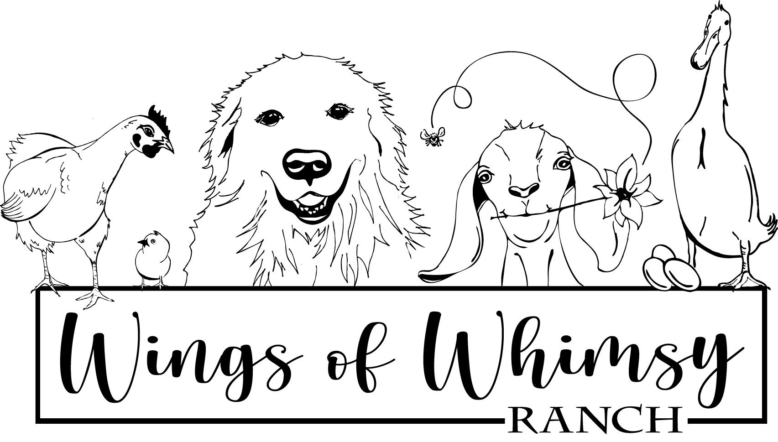
Wings of Whimsy Ranch, LLC. - 7920 Hygiene Road, Longmont, CO 80503 - (734) 417.6755
CONTRACT FOR CANINE STUD SERVICE
Date of Contract:
Date(s) of Breeding:
Expected Due Date:
Stud Dog Information

Registered Name:____________________________________________________________________
Nickname:________________________________Registration#:_____________________________
Owner Name:_______________________________________________________________________
Address:____________________________________________________________________________
Contact Number:____________________________________________________________________
Email:_____________________________________________________________________________

Bitch Information

Registered Name:___________________________________________________________________
Nickname:________________________________Registration#:_____________________________
Veterinarian Contact Info:____________________________________________________________

Owner Name:______________________________________________________________________
Address:___________________________________________________________________________
Contact Number:___________________________________________________________________
Email:_____________________________________________________________________________

Stud Contract Terms and Conditions
The stud fee for service is:
( ) $1250.00

Or

( ) first pick of the litter (male/female), determined by stud owner
Stud owner agrees to the following:
1. To have the stud dog current on all vaccinations, worming, flea and tick control
2. To provide documentation of OFA test results and a clear Brucellosis test
3. To provide pictures and a copy of stud dogs registration papers
4. To take good care of the bitch while in our charge
5. To provide up to (2) return stud services to the same bitch if no pregnancy results
from the mating at no charge. Please notify no more than 70 days following the
mating. If the stud dog is no longer available for whatever reason for return
service, a full refund will be provided to the bitch owner
6. To sign and return litter registration promptly
7. To provide a written service memo and record of breeding dates
Bitch owner agrees to the following:
1. To pay the agreed stud service fee before the bitch is serviced or if agreed upon the
first pick of the litter
2. To provide veterinary certificate of current annual vaccinations, including a clear
Brucellosis test
3. To provide bitch registration papers before servicing
4. To send bitch in good health and in season
5. To notify stud dog owner no later than 70 days after mating if no pregnancy
results from mating.
6. To take appropriate care of bitch after breeding to ensure no other males could
mate her accidentally before her mating season is finished
7. To care for all puppies whelped as a result of this mating until they reach at least 8
weeks in age.
8. To not knowingly sell or transfer puppies whelped as a result of this mating to any
person or firm connected with the business of resale or wholesale of dogs
Other conditions:
One puppy born alive or dead constitutes a litter. However, if only one puppy results from this mating, a return service will be provided at no charge to the same bitch at her next heat or within a year, provided all conditions of this contract have been met. If the bitch fails to conceive on the return service, this contract is terminated.
Both parties agree to all the contract terms and conditions mentioned above
SIGNATURE OF STUD OWNER:_______________________________DATED:________________
SIGNATURE OF BITCH OWNER:_______________________________DATED:_______________

